Contents Table

1. **Introduction………………………………………………………….5**
   1. Hire me Diagram Train me Diagrams ………………………5
2. **Interface of Program………………………………………………..6**
3. **Interface of program Images……………………………………….7**
4. **About Machine Learning ………………………………………… 8**
   1. 4A.Which Category of Machine Learning ? …………………8
   2. 4B. How does Cascade Classifier Works? …………………8-9
      1. *4B.1 My experience with Cascade Classifier …………..9*

c. 4C. How does Knn(k-nearest neighbors) Classifier Works? …9-10

1. **Why to Use? …………………………………………………………...10**
   1. Why Knn ? ……………………………………………………. 10
   2. Why Cascade classifier? ……………………………………… 10
2. **Functions and Classes ………………………………………………..10**
3. **Weakness Of the Program …………………………………………..11**
4. **Sources: ……………………………………………………………….12**

# Introduction

The medical Mask started to became part of our life. When we need to go outside, work, shop or to pay bill we need to have the mask with us. Because of epidemic disease Covid-19. But there are some citisiens that dont pay enough attention to wear their mask. The government already have been doing the control with security members but since our job is making everything automated we decided to make a machine learning Project that will control if the person is wearing it or not. According to the result we would have some alert to the citisiens so that they would wear their mask.

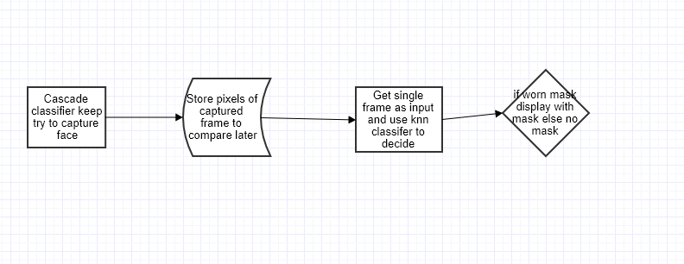

“hire me” diagram

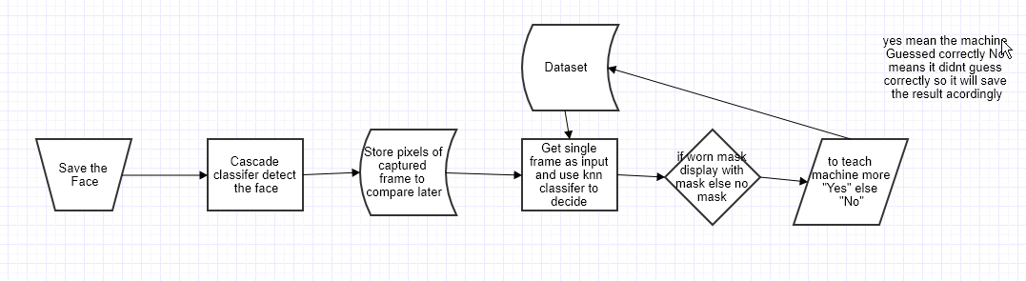

“train me” diagram

**2.Interface of Program**

For the gui of the program I have used tkinter module of python. The gui part is done in the “getFaceImg.py” of the “CamToPix” folder. We have used Tkinter because it is easy to import video frame by frame that is captured using opencv.

When first time the main project is run, There is a description part about the project and there are two buttons “Train me ” and “Hire me”. Frames to in it and by creating Labels frames we can show images text and button on the screen easily.

*Train me:* It lets the user the add more sample to dataset. Also it capture the face using a button for user to have more control. Unless “Yes” and “No” buttons are not clicked the sample will not be saved to Dataset. The user will need to click the button “Save the Face” to get 96X96 pixels of the face.

*Hire me:* more automated use of the program. It capture the face anytime a face or a object look like face is in the range of camera. It captures the 96X96 pixels face photo and put it through some process to have predict on. The result will be “With Mask” or “No Mask”. Then it will capture new image to do the same process.

“*Restart”* that takes the program to the first window

*“Randomize”* mixes the dataset in to make sure the samples are randomized because we have last 20% of data as test to make accuracy much right we need to randomize dataset.

*“Sound On”* or *“Sound Off”* when the face is captured the sound play. If with mask is not worn WearMask.mp3[2] plays otherwise if mask is worn Thanks2Wear.mp3[3] plays.

*“Save The Face”* is the button when clicked captures the image 96X96 pixel of human face. If the image is not captured the user should get closer or further to the camera and look straight to the camera.If the Face Image is Captured the Image will appear right next to buttons. and below those button “Yes” ,”No” Buttons will appear. Above the image The text says “with mask” or ”No Mask” below the accuracy of the prediction and below the accuracy text number of samples negative and positive the part train and test for both of them negative and positive samples will appear as number. If the Image has mask and the text is “with mask” then if user wants to save this image’s pixels to dataset the user should click “Yes” which will save the dataset. Once “Yes” is clicked “No” cannot be clicked. The color of the button will already change to red while the other one stays same.”Yes” doesnt mean save to dataset or save as with mask to dataset.

if yes is clicked “self.OneorZero “ which is state 0 or 1 will directly be saved to last column of the dataset.

if no is clicked “(self.OneorZero +1)%2” is saved to last column of dataset right next to equivilent pixels of the face image.

Images of program:

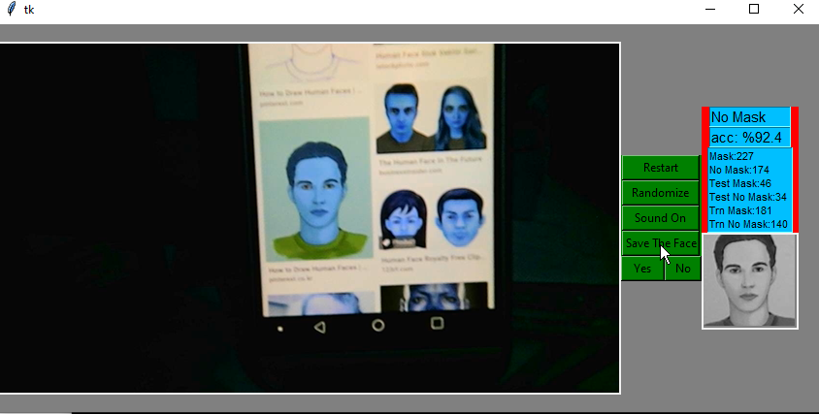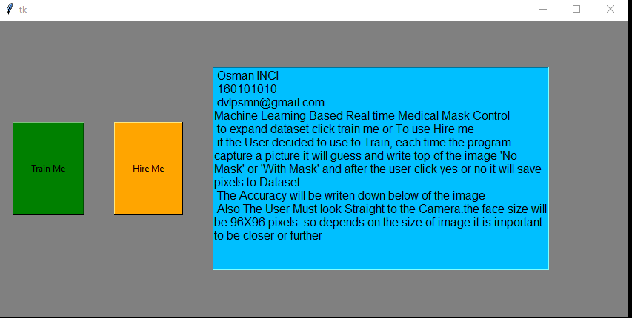

**3.Dataset**

The data of all samples are stored in the “data/Dataset.csv” file on the directory with the main project. The dataset can be created by user if there is no data on the dataset file. That time the user will click “Train Me” and when the user is in fornt of camera and face is detected by camera(*if the face is not detected the user must get closer or further to be in range of the camera* and try again) user will click “Save the Face” button the pixels of the captured face will be saved then all the pixels will be read to be writen to file “data/Lastphoto.csv” file to be predicted later. If the dataset has less than 10 samples then the prediction will be done randomly(0 or 1). This will be shown to user 1: “With mask” ; 0:”No mask” when the user Click “Yes” or “No” button this pixel of the face will be saved to Dataset also its label(0 or 1). The number of sample in the dataset will increase. Also all information about dataset (number of mask samples, no mask ,train mask ,train no mask ,test mask and test no mask sample) will appear right next to the button that captures the face. The accuracy of the image shows over those information under the “With Mask” or “No mask” text, The accuracy is ”-1” if the dataset is empty.

*Randomize dataset*: when we do train the program we capture a picture and get its pixel then get input from user 0 or 1 respectively “No mask” or “With mask”. But lets suppose we have done last %20 as no mask which is 0. İt means we have last test data alone with sample of “No mask”. To escape from this situation we need to randomize dataset. We could do always after a new value if recorded. But it is much better we do with different button on the interface to escape unnecessary use of cpu since we need to read whole the data of dataset. We have used random function of python. We do shuffle. First read all samples from “Dataset.csv” file then save all values to an array later shuffle them and write all element of this array back to ”Datase.csv” file. This process takes some time up to the Length of samples. That is why better to not do this unless we dont really need it.

4. **About Machine Learning**

Machine learning is the study of computer algorithms that improve automatically through experience. It is subset of Artificial Intelligence. Machine learning algorithms are based on mathematical model based on sample data known as training data to make predictions without being programmed explicitly. There are Three category of Machine learning[1].

*1->Supervsied Learning:* The Program is taught to predict later. We need to have dataset. Negative and positive samples. And also labels that will classify those samples.

*2-> Unsupervised Learning:* There is dataset without Labels. So the program will find it itself.

*3-> Reinforcement Learning*: The program interacts with dynamic environment. There is no dataset.

**4A.Which Category of Machine Learning ?**

In the begining when My dataset is empty It seems it could be Reinforcement learning. But from the first sample I create Dataset and a label for it. So I will have large data and labels with. This would be use Supervised learning Since I have Dataset and Labels. Also, Because I have used*Knn(k-nearest neighbors) Classifier* and *HaarCascade Classifier* ,those are implemented by Supervised of machine learning.

**4B. How does Cascade Classifier Works?**

Haar cascade is a machine learning classifier that is trained by having positive and negative samples. Then we let the program to scan all the image by a window end of this we have some features that makes the sample positive or negative. There are edge,line and center surrounded features that gets the pixels in the current window on the image and apply some classifiers. In move of each window some stages are created. Those stage will be steps to decide for the object later. Next time if we want to check the image is negative or positive it simply gets the window and scan on the image. If all the stages are passed then the sample would be positive if not it will be negative. Once a stage is not passed it doesnt check for the next stage simply it returns negative for the current object. There are Haar cascade file that detect faces in Opencv Module of python. I have used One of those xml file that is already provided by Opencv that is in same directory with main file in the “data/haarcascade_frontalface_default.xml”. It detects frontal face of human. It provides 96X96 pixel image using “haarcascade_frontalface_default.xml” feature file. After Having 96X96 pixel frontal face image I am done with Haarcascade classifier. [4]

**4B.1 My experience with Cascade Classifier**

I have decided to make new cascade classifier that will detect sheep face(). To have experience with and make sure that I understand Cascade classifier. I am using windows so I need to make this on windows which is more difficult than linux system acording to my research. But for windows there are tools can do this job. I have used “Cascade-Trainer-GUI” to get my own cascade ready. I have collected 100 positive pictures of the face and there must be at least 200 pictures of negative or background pictures which I had 220 of negative pictures. I have realize that when I am getting positive I must get certain picture of object that I want to detect. In this case sheep face I needed to get exactly the face as positive. The window was set 24 height and width which was reccomended. Actually, setting this acording to aspect ratio of positive pictures was also reccomended. Also number of stages was defined by us on the tool. I have realized that when number of stages are less the quality of the haarcascade is higher to detect exact object. But it takes time to do traning process. But still it is ok because the traning is done for one time. If I need to tell about the result was I able to detect faces? Yes, But so many times it would get other objects on the camera as face. Which made me think that actually I need to set 30 stages and maybe more positive samples. Also it is difficult to run this in real time because so many times the place sheeps are crowded which means one’s hair closer to others face. And the faces are not very different than the hair. So it is really difficult to train for this sample. But trying this deffiently taught me more about Cascade classifier.

4C. **How does Knn(k-nearest neighbors) Classifier Works?**

The basic of Knn algortihm is that similar things would look like each other. Since we are working on the human face there are eyes over mouth and it is like that for everyone as We have mentioned above we get 96X96 pixel of human face if I get all pixels of this Picture approximitally the eyes and mouth will be around same area. It is what Knn algorithm about. And in case of human face when wear mask the place around mouth will be covered. which means the pixels around this area would be similar on the image(96X96 pixel face image). All the pixels of the image would be features and wearing mask(1) not wearing mask(0) will be label. The label will be at last column(9217th column) of the Csv(comma-seperated-Values) file . The dataset will be filled by those values. And the program will be able to classify it acoriding to the dataset. The value of neighbors is given squareroot of whole the dataset. The Knn part is done in the Project file Named “MLAPI.py” in the CamToPix folder.

*Traning and Testing Dataset*: The trainin data is needed to use in knn classifier. And the training data is 80% of the whole dataset. Which is the first 80 percent of the dataset. The rest %20 percent is left to use for test since the test data and traing must be different.

*Calculation of accuracy:* The accuracy is calculaated using the modulue sklearn which we get knn classifier from. It gets samples from the test and do calculation. The math behind the sklearn accuracy_score is easy to implement. When the program do predictions some of the predictions are true and false. There are four variables: true positive,true negative,false positive and false negative. The accuracy is (true positive +true negative)/( true positive+true negative+false positive+false negative)

5. **Why to Use?**

**Why Knn ? :** I had some experience about use of Knn but because of limited time of the previous project I was not able to dive in to deep of the classifier. I was plan that if I do new project using this classifer I would Understand much more detail about Mahine learning and the classifer, which was true thinking. After this project I have much more information about Knn.

**Why Cascade classifier? :** When I started to have research about How Can I detect Human face it was the classifer appears to be used frequently since it is implemented with OpenCv easily. Also this is new method for me to do traning. When I dived into detail I realized that it is actually the base idea of Cnn classifier which is one of the best Deep Learning algorithm.

6. **Functions and Classes**

**Funciton Main():** It is the main part of the program. To make resart easier and to keep the codes simple I decied to use this function in the main part of the program that it does basic things imports both Machine Learning part and Gui part of the program. I have Object of Gui part of the program to access the first function to run it.

**Class Camera():** The Gui part , recording by default camera ,capture process and Cascade classifier parts are done in this class. Also it is where we connect to machine learning part of the program to use Knn classifier to make prediction on the pixels that are already saved to csv files.

**Class MachineL():** Here we have knn part of the program. It gets pixels from the csv file for both current sample and whole the dataset to make predictions.

7. **Weakness Of the Program**

1. We use knn Classifier which is supervised learning method that needs data with labels. Each sample is 96X96 pixels of image which is 9216 pixels and 9217th column is label(0 or 1). The larger number of samples would decrease the speed of the program since it takes time to do predictions.

2. About the Cascade Classifer it gets only straigt pictures. If rotation of image is different than straight it doesnt recognize the face. To develop we need to train the program to get faces when rotated. Upside down , left and right image. Right now we have one that detect straight face.

**8. Sources:**

[1] <https://en.m.wikipedia.org/wiki/Mahine_Learning>

<https://Kaggle.com/shrey821/digit-recognition-using-cnn-model>

<https://youtube/PmZ29Vta7Vc>

<https://towardsdatascience.com/machine-learning-basics-with-the-k-nearest-neighbors-algorithm-6a6e71d01761>

<https://towardsdatascience.com/whats-the-difference-between-haar-feature-classifiers-and-convolutional-neural-networks-ce6828343aeb>

[2] <https://youtu.be/AdUEUXKl-S4>

[3] <https://youtu.be/2ebzZj1e2WQ>

<https://towardsdatascience.com/understanding-data-science-classification-metrics-in-scikit-learn-in-python-3bc336865019>

[4] The OpenCV Reference Manual Release 3.0.0-dev /CHAPTER EIGHT/OBJDETECT. OBJECT DETECTION/8.1 Cascade Classiﬁcation